DATA 430 Technical Report  Assignment 3: Decision Trees | Russell Larkin
Predicting Obesity Classifications with Decision Trees
URL to dataset: https://archive-beta.ics.uci.edu/dataset/544/estimation+of+obesity+levels+based+on+eating+habits+and+physical+condition
This template should be used in conjunction with the assignment instructions. The size of the text area below will expand to the length of your response; the area should not be interpreted as a required or suggested length of response. Responses within the text area should be single spaced with Times New Roman 12pt font. The body of the document will likely be 6-9 pages, not including the Appendix; length may vary depending on specifics of the analysis and the dataset. As needed, APA format in-text citations should be included, along with a full references list at the end of the document.
Overview
Problem Domain: give some background and context about the problem domain (application area). For instance, if you are doing the analysis for predicting heart disease, provide some context about the disease and include some interesting statistics about it. Also, discuss how the method is relevant for the chosen problem.
Obesity is a growing global public health concern, closely linked to an increased risk of chronic diseases such as type 2 diabetes, cardiovascular disorders, musculoskeletal issues, and certain cancers. According to WHO, worldwide adult obesity has more than doubled since 1990, while adolescent obesity has quadrupled, and as of 2022, 43% of adults were overweight and 16% obese (WHO, 2025). The condition is driven by factors including genetics, dietary habits, physical activity levels.
The rise in sedentary lifestyles, increased consumption of calorie-dense foods, and lack of regular exercise have contributed to escalating obesity rates. As healthcare systems face mounting costs and patients endure long-term health consequences, early identification of risks becomes essential. Predictive modeling using machine learning offers a scalable, data-driven method to assess obesity risk based on individual habits and attributes.
Decision trees are particularly suitable in this context, as they can handle mixed data types (numerical and categorical), tolerate missing or noisy values, and provide clear, interpretable rules that mirror human decision-making. These traits make decision trees an appropriate choice for modeling health-related conditions where transparency and the ability to interpret model decisions critical to clinical and public health applications.

Objective: clearly state the objective of the analysis in relation to the kind of algorithm you are employing. Use specific language as to what question(s) you are trying to answer using the specific analysis/modeling type.
My primary research question is:
“Can a person’s dietary habits, physical activity levels, and lifestyle patterns be used to accurately classify their obesity risk category?”
The objective of this analysis is to develop a decision tree classification model that predicts an individual’s obesity level (the NObeyesdad multi-class target variable) using self-reported demographic, behavioral, and physical activity metrics. The dataset includes the following variables:
- Demographic & Physical Metrics: Height, Weight, Gender, Age
- Habit Metrics: family_history_with_overweight, FAVC, FCVC, NCP, CAEC, SMOKE, CH2O, SCC, TUE, CALC, MTRANS.
- Physical Activity Metric: FAF
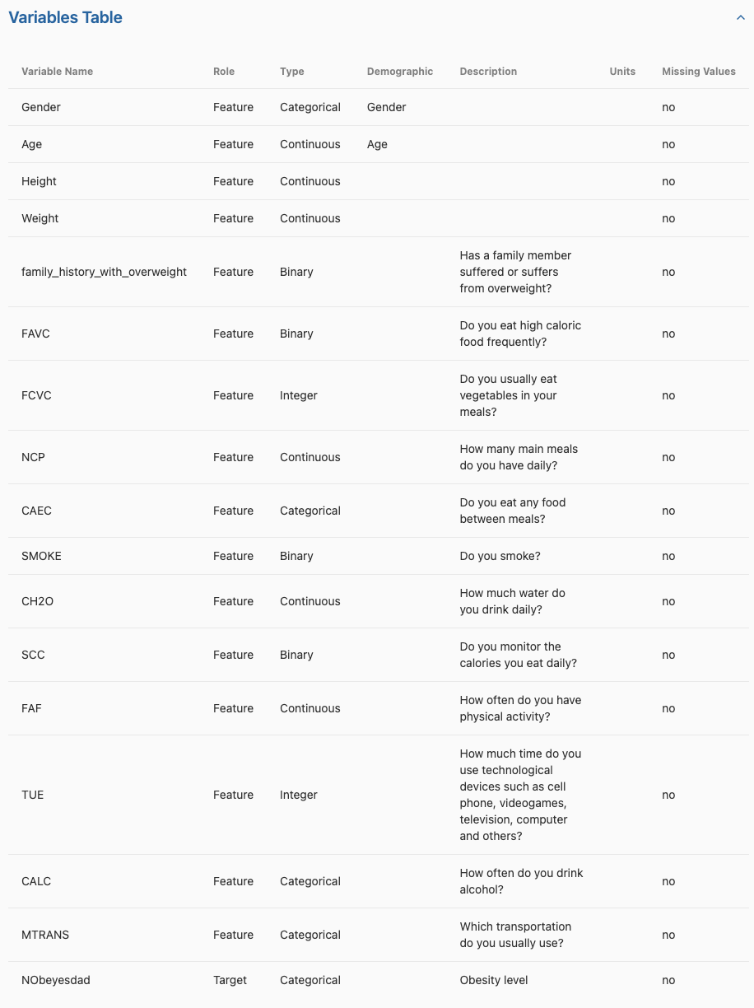
Figure 1: Full feature description table.
Decision trees are well suited to this type of classification problem because they manage mixed data types, uncover non-linear patterns, and produce interpretable rules that can inform professionals in public health and clinical settings.
I will (1) perform exploratory data analysis utilizing heat maps to understand feature distributions and identify patterns, (2) utilize k-means clusters to engineer features that add weight to lifestyle choices effect the target feature, (3) experiment with boosting and random forests to further improve model accuracy, and (4) evaluate predictive performance via accuracy, precision/recall, F1, confusion matrix, and cross-validation.

Analysis
Exploratory Analysis: describe the data including the source, the collection method, and variables. Perform exploratory analysis. Also, select few key variables (including the target variable for supervised learning) and study their distributions using plots such as histograms, box plot, bar chart, etc.
Data source and collection method: I used a publicly available dataset (Estimation of Obesity Levels, 2019) with 2,111 individual records. 77% of the data was generated synthetically using the Weka tool and the SMOTE filter, 23% of the data was collected directly from users through a web platform. Data included my target variable (NObeyesdad), and 16 features (types: categorical, continuous, integer, binary) which classified individuals into seven obesity levels ranging from “Insufficient_Weight” to “Obesity_Type_III.” Features included 4 demographic metrics, 11 habit metrics, and 1 physical activity metric. There are no missing values in the dataset, and all variables are cleanly formatted.
I computed pairwise correlations among all predictors (not just target vs. feature) and confirmed that no two features exceeded |r|≈0.8. In doing so, the model is guarded against the variance‐inflation and coefficient‐instability issues that come with extreme multicollinearity.
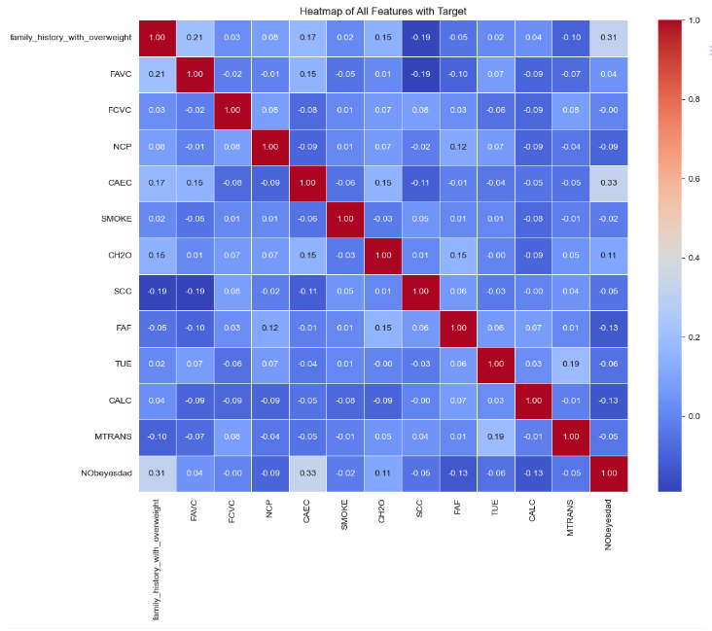
Figure 2: Target Correlation Heat Map

The following visualizations guided feature selection and preprocessing strategies, helping identify trends and outliers and informing decisions:
The class distribution reveals a strong skew toward overweight and obese categories, with relatively fewer instances labeled as Normal_Weight or Insufficient_Weight.
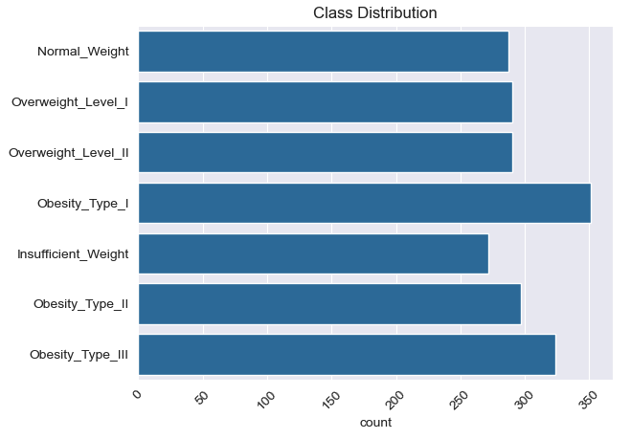
Figure 3: Class Distribution of Target Across Instances.

What I changed immediately:
- I removed the four demographic variables as they were not useful to my target question. I wanted to know what dietary habits, lifestyle choices, a activity levels resulted in weight gain. I didn’t believe the individuals current weight, height, age, or gender were useful features to answer that question. Additionally, the height and weight (factors used to calculate BMI) had too strong of a correlation to the target.

Feature exploration included a variety of graphs to identify important features:
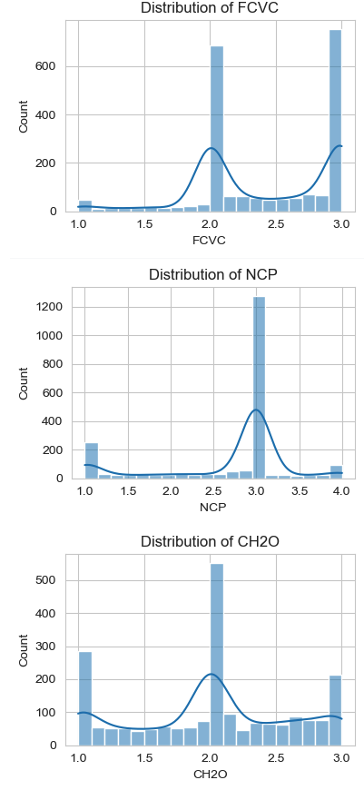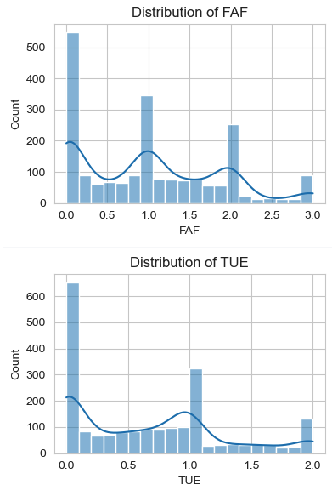
Figure 4: Distribution of Numeric Features
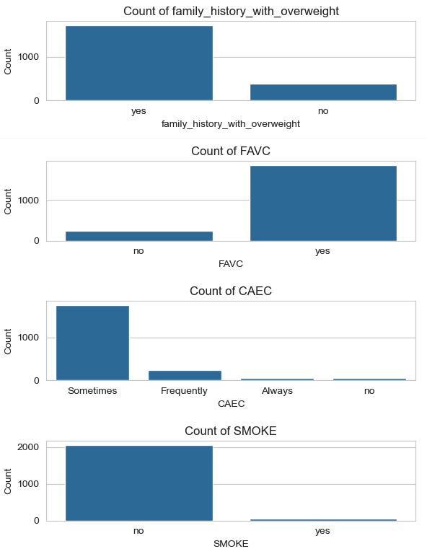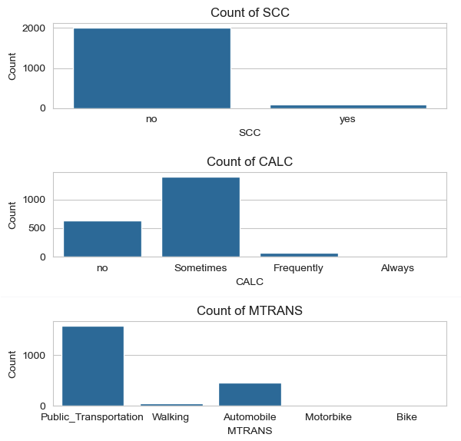
Figure 5: Categorical Feature Distribution

Exploratory visualizations revealed clear behavioral and lifestyle trends tied to obesity levels. Histograms highlighted skewed usage patterns (e.g., high tech use and low movement). Bar graphs showed data what highly skewed, which may affect the model. Some features like SMOKE and family_history_with_overweight were imbalanced or low-variance, others like CH20, FAF, and TUE provided concentrated, class-specific signals that likely contributed heavily to the model’s structure and accuracy.
I created additional features using sklearn KMeans clusters to create behavioral profiles from related features.:
- X['healthy_cluster'] = kmeans.fit_predict(X[['CH2O', 'FAF', 'FCVC', 'NCP']]):
- X['indulgence_cluster'] = kmeans.fit_predict(X[['SMOKE', 'CAEC', 'CALC']]):

These clusters should were an attempt to explicitly model interactions between inputs. In my case, these clusters had low feature importance and they were not as predictive as I had hoped, however, I left them because they still slightly improved model performance.

Preprocessing: armed with the exploratory analysis, perform the necessary preprocessing, both general and specific types appropriate for the modeling type being employed.
I initially experimented with DecisionTreeClassifier and RandomForestClassifier. but observed low precision, recall, and F1-scores, particularly for the Obesity_Type_I and Obesity_Type_III classes. I also tested SMOTE to address class imbalance, but this significantly widened the gap between training and test accuracy (a sign of overfitting).
SMOTE introduced many unrealistic decimal values in originally discrete behavioral features like NCP, FAF, and TUE. To reduce noise while preserving subtle variation, I rounded these features to two decimal places. This led to noticeable gains in accuracy and precision by while maintaining enough resolution for XGBoost to identify meaningful splits.
I then transitioned to XGBoost’s XGBClassifier to improve accuracy by combining multiple weak learners into a strong ensemble. Each new tree focuses on correcting the errors of the previous ones, which enhances performance, especially on samples that are hard to classify.
After tuning the XGBoost model by adjusting max depth and regularization parameters, the gap between training and test accuracy decreased substantially, from over 15% to just 8%. Final scores reached 83% on training data and 75% on test data, indicating improved generalization and reduced overfitting. I believe this level of performance is acceptable for a multi-class classification problem with noisy, self-reported features.

Model Fitting: explain the key steps and activities you perform to fit the model. Experiment (as appropriate) with parameters tuning. This is key, what separates highly accurate model from a less accurate ones is the amount of performance tuning performed.
All code can be found in my Google Colab Notebook:
RLarkin - Assignment 3 Google Colab

Initial model fitting involved:
- Splitting the dataset into 70/30, train/test. This provides a good balance between having enough data for training and a sufficient sample for evaluating model performance.
- Using xgboost with XGBClassifier.

The model was initially trained using default parameters, then refined by:
- Adjusting max depth from 5 to 3 to create simpler, broader patters, to reduce overfitting.
- Adding subsample of 0.8 to add randomness.

I attempted to adjust n_estimators from 100 to 50, to help reduce the model’s complexity and prevent overfitting, but it negatively affected my classification report and confusion matrix with my adjustments already made to the max depth.
Results
Model Properties: explain the components of the fitted model and their characteristics. Leverage functions to summarize the model properties. Also, leverage visualization as required.
The final model was trained using XGBoost’s XGBClassifier, a gradient boosting implementation known for its accuracy and efficiency with spreadsheet data. XGBoost built a group of shallow decision trees with each new tree correcting errors made by the previous one. The key benefit is that it balances model flexibility and robustness through iterative learning and regularization.
The decision tree visualization shows a single XGBoost decision tree (tree 0). This plot shows how the model splits based on key features like NCP, FAF, and TUE. Each node represents a decision threshold, with red edges leading to higher predicted class values and blue edges leading to lower ones. This structure illustrates how the ensemble learns rules from combinations of behavior indicators.
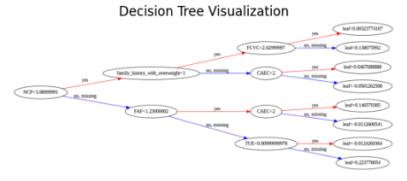
Figure 6: Visualization of a single XGBoost decision tree.

Feature Importance (below) displays the ranked feature importance scores from the XGBoost model, based on F-score (how frequently each feature is used to split). Time spent using technology (TUE), daily water intake (CH2O), and frequency of physical activity (FAF) were the most impactful features.
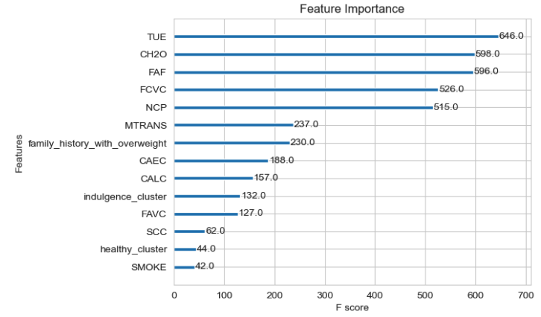
Figure 7: Feature Importance Report

The model was configured with the following key parameters:
- max_depth = 3: Limited tree depth to reduce overfitting and capture broader decision patterns.
- subsample = 0.8: Added randomness to the training process by using only 80% of the data per tree, improving generalization.
- n_estimators = 100: Capped the number of boosting rounds at 100.
- learning_rate = 0.1: controlled the impact of each new tree in the boosting process.

After parameter tuning, the model contained 100 tress with a depth of 3, resulting in a moderately complex ensemble capable of capturing non-linear relationships in the data without overfitting.

Output Interpretation: explain the result and interpret the final model output using terms that reflect the application area and in relation to the stated objective. This is where you check whether or not the stated objective is met.
The XGBoost model achieved its objective of predicting an individual's obesity classification using self-reported lifestyle and behavior features. Final performance reached 83% accuracy on training data and 75% accuracy on test data, with a macro F1-score of 0.74 and weighted F1-score of 0.75. This demonstrates that the model generalized well across multiple class labels.
Performance varied across the seven obesity categories:
The model performed extremely well for Obesity_Type_I (Class 4), achieving 94% precision and 100% recall, indicating a high ability to identify this group with confidence and completeness.
- Intermediate categories such as Overweight_Level_I and II showed strong performance, especially in recall, reflecting the model’s ability to distinguish individuals with moderate weight conditions.
- Performance dropped for the most severe classes, particularly Obesity_Type_III (Class 6) and Obesity_Type_II (Class 5), with recall scores of 53% and 54% respectively. This suggests some difficulty separating higher-risk individuals, likely due to overlap in behavioral patterns.
- The model also correctly identified Normal_Weight and Insufficient_Weight cases with respectable F1-scores of 0.72 and 0.81.
Obesity classes will share overlapping features, especially in self-reported lifestyle data. Still, the model demonstrated strong overall classification understanding and was especially effective at identifying mid risk individuals based on their reported habits.

Evaluation: employ appropriate metrics to quantitatively evaluate the performance of the fitted model. For supervised classification, this includes simple accuracy, precision & recall (or sensitivity & specificity), all of which can be generated from a confusion matrix, or ROC.
XGBoost’s performance was evaluated using standard multi-class classification metrics: accuracy, precision, recall, and F1-score. These were calculated for each of the seven obesity categories defined in the target variable (NObeyesdad).
- Overall test accuracy: 75%
- Macro-averaged F1-score: 0.74
- Weighted F1-score: 0.75
The strong alignment between Macro and Weighted F1 scores suggest that performance was relatively balanced, even with class imbalance present.
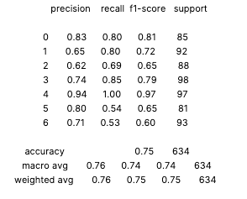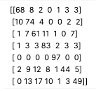
Figure 8: Confusion Matrix and Classification Report

These metrics confirm that the model reliably detects early and moderate obesity categories, while performance slightly drops for the most severe classes (Type II and III).
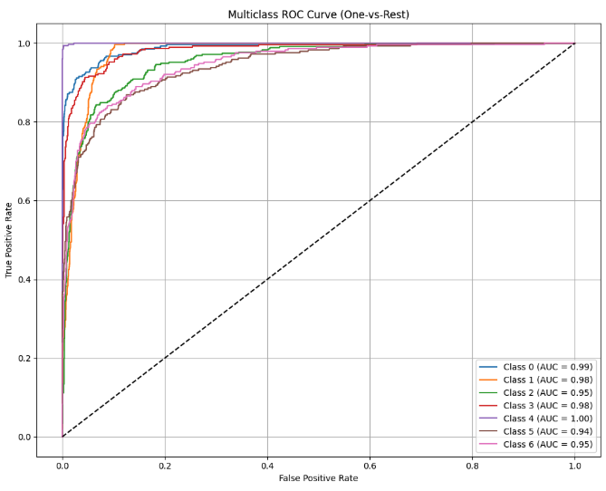
Figure 9: ROC Curve.
The ROC curve illustrates how well the model distinguishes each obesity class from the rest by plotting the true positive rate against the false positive rate across all thresholds. The diagonal line represents random guessing, while curves that hug the upper-left corner indicate strong discriminative power. All seven classes achieve area under the curve (AUC) scores above 0.94. This means the model can almost always rank true instances of that class higher than false ones. The consistently steep and separated ROC curves across all classes indicate that the model performs exceptionally well at identifying individuals across the full range of obesity categories in complex, imbalanced, multiclass setting.
Cross validation confirmed a mean accuracy of .728 across the folds. Overall, these evaluation results validate the model’s suitability for use in health applications where behavior-driven predictions are needed and perfect separation between categories is not always achievable.

Conclusion
Summary: highlight the main findings in relation to the stated objective. You don’t need to discuss the details of the analysis and the model such as accuracy here, just focus on the key findings.
In summary, the XGBoost classification model achieved strong performance in predicting obesity levels based on behavioral and lifestyle data. By engineering features and tuning key parameters, the model reached 83% training accuracy and 75% test accuracy, with a macro F1-score of 0.74. It was especially effective at identifying moderate obesity categories, such as Obesity_Type_I, where both recall and precision exceeded 90%.
The most predictive features included hydration (CH2O), physical activity (FAF), time spent using technology (TUE), and dietary behavior (FCVC, NCP), all of which align with well-known public health guidance. This reinforces the model’s relevance and supports its potential use in screening tools, especially where self-reporting is the only option.
The project successfully met its objective: to classify obesity risk levels using lifestyle indicators alone, while maintaining accuracy, generalization, and transparency. These results demonstrate the value of tree-based models for health behavior modeling and risk classification tasks.

Limitations & Improvement areas: discuss the limitations of the analysis and identify potential improvement areas for future work. This could be related to the data, algorithm, or a combination of the two.
I believe the model’s limitations were as follows:
- Approximately 77% of the dataset was synthetically generated using SMOTE. Although this helped balance class distributions, it may have introduced artificial patterns that do not reflect real-world variance, particularly in harder-to-distinguish classes like Obesity_Type_II and Obesity_Type_III.
- Data relies entirely on self-reported behaviors, which are subjective and prone to individual bias or underreporting.
- Misclassifications can occur between adjacent obesity levels where behavioral profiles can look similar.
Future improvements could include:
- Use fully real-world data from validated clinical or survey sources to increase reliability and robustness.
- Reduce the number of levels in the target variable to cleanly separate borderline cases.

Appendix
All code can be found in my Google Colab Notebook:
RLarkin - Assignment 3 Google Colab


Figure 1: Full feature description table.


Figure 2: Target Correlation Heat Map


Figure 3: Class Distribution of Target Across Instances.
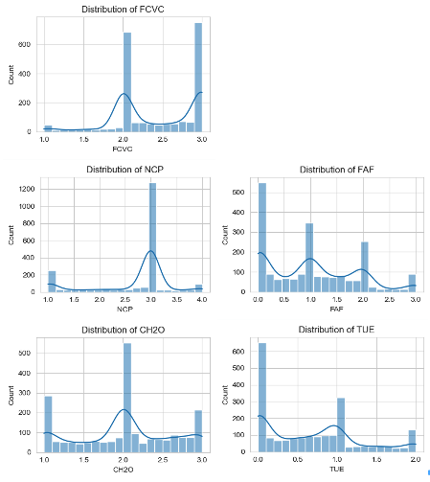
Figure 4: Distribution of Numeric Features

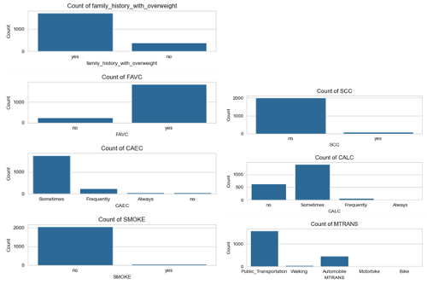
Figure 5: Categorical Feature Distribution


Figure 6: Visualization of a single XGBoost decision tree.


Figure 7: Feature Importance Report


Figure 8: Confusion Matrix and Classification Report

Figure 9: ROC Curve.

References
World. (2025, May 7). Obesity and overweight. Who.int; World Health Organization: WHO. https://www.who.int/news-room/fact-sheets/detail/obesity-and-overweight

Estimation of Obesity Levels Based On Eating Habits and Physical Condition [Dataset]. (2019). UCI Machine Learning Repository. https://doi.org/10.24432/C5H31Z

GeeksforGeeks. (2024, May 3). SMOTE for Imbalanced Classification with Python. GeeksforGeeks. https://www.geeksforgeeks.org/machine-learning/smote-for-imbalanced-classification-with-python/

GeeksforGeeks. (2024, February 22). Random Forest Algorithm in Machine Learning. GeeksforGeeks. https://www.geeksforgeeks.org/machine-learning/random-forest-algorithm-in-machine-learning/

GeeksforGeeks. (2019, August 19). Implementation of XGBoost (eXtreme Gradient Boosting). GeeksforGeeks. https://www.geeksforgeeks.org/machine-learning/implementation-of-xgboost-extreme-gradient-boosting/

Overview and Objective — Level: L3
After thoroughly reviewing the report, I determined that the overview and objective meet the criteria for Level 3. The submission provides a clear problem domain description, offering some useful background about obesity, including trends, health consequences, and societal relevance. The explanation of why decision trees are appropriate is reasonable and mentions key attributes such as handling mixed data types and interpretability. However, the objective section, while present, combines various elements beyond decision trees—such as boosting, random forests, and XGBoost—which fall outside the scope required. The rubric specifies that the objective should directly align with the chosen model type, in this case, decision trees, but the work introduces and centers its objective around other models. The inclusion of these other models dilutes the clarity of the decision-tree-specific objective, and this deviation prevents achieving a higher level. A Level 4 or 5 would have provided a focused, precise objective tightly coupled with decision trees alone, offering more depth regarding the research question solely within that framework. To improve, I would like to see the objective narrowed down to address decision trees specifically, with discussion limited to their role and contribution to solving the stated problem, avoiding the addition of other model types unless directly linked to decision trees.

Exploratory Analysis and Preprocessing — Level: L3
Upon evaluation of the exploratory analysis and preprocessing components, I am assigning Level 3. The analysis does cover the necessary loading of libraries and data, and there is evidence of descriptive exploration using heat maps and distribution plots. The report describes class imbalance, skewness, and correlations, which shows awareness of the data’s structure. Preprocessing steps are mentioned, such as handling synthetic data issues and attempts at SMOTE, as well as clustering feature engineering. However, the rubric emphasizes correct loading of data and libraries along with thorough, appropriate preprocessing specific to the chosen model—decision trees. In this report, the preprocessing is largely designed to support gradient boosting rather than decision trees directly. The use of SMOTE and cluster-based features seems excessive and misaligned for plain decision tree modeling. Furthermore, it is unclear whether the preprocessing steps were appropriately limited to what decision trees require (given their ability to handle unscaled, mixed-type data). The reliance on external techniques like SMOTE introduced complications (overfitting, unrealistic values) that do not reflect a preprocessing strategy optimized for decision trees. To achieve a higher level, I would expect a tighter preprocessing workflow tailored specifically for decision trees, along with more focused justification of preprocessing choices in that context.

Model Fitting — Level: L2
Based on the rubric, I am assigning Level 2 for model fitting. The reason for this is that the key steps related to decision tree fitting are largely missing or overshadowed. The report focuses extensively on XGBoost and Random Forests, which, while tree-based, are not the same as fitting a decision tree as specified in the assignment. The narrative discusses parameter tuning and model adjustments for XGBoost, including changes to max depth, subsample, and n_estimators, but omits detailed coverage of fitting and tuning a standard decision tree model. The rubric specifies that key steps relevant to decision trees must be included, with proper performance tuning and experimentation. In this case, the report does not demonstrate decision-tree-specific parameter selection (such as criteria choices, max depth, min samples split/leaf tuning) or learning curve analysis related to a standalone decision tree. Additionally, experimentation with decision tree hyperparameters is not presented in any meaningful way, limiting the depth and rigor expected for Level 3 or above. Improvement here would involve focusing on the decision tree model fitting process, showcasing the choices made, tuning steps, and their impact on performance.

Results and Interpretation — Level: L2
For the results and interpretation section, I assign Level 2. The report describes the components and properties of an XGBoost model, including visualization of a boosting tree, feature importance, confusion matrix, and ROC curves. However, it does not provide a thorough and correct explanation of the properties of a fitted decision tree model, as required by the rubric. Major sections that should cover decision tree components, such as node splits, depth, Gini or entropy criteria used, and the logic of its learned rules, are absent. The interpretation focuses on an ensemble model rather than on what a standalone decision tree reveals about the problem or how its decisions align with the objective. The rubric calls for correct addressing of required sections with clear interpretation relative to the original decision tree model, which is missing. To achieve a higher level, I would expect detailed interpretation of a decision tree’s structure, supported by clear visualizations of that model, with direct links to the stated objective.

Conclusion — Level: L3
I am assigning Level 3 for the conclusion. The conclusion provides a reasonable summary of findings, linking them back to the original question about predicting obesity risk from behavioral and lifestyle indicators. The narrative does mention key contributing features and reflects on the practical value of the model. However, as specified by the rubric, a higher-level conclusion would focus entirely on lessons learned from applying decision trees rather than other models. The summary here blends insights from XGBoost and decision trees without clear distinction, which limits the precision expected. A more decision-tree-focused reflection, highlighting its specific strengths, weaknesses, and lessons learned from its application to this problem, would elevate this section to Level 4 or Level 5. Additionally, the limitations and future work section, while thoughtful, also does not center decision trees as required.

